Semaine13

(stock-predictor) Gilles@patricias-macbook-pro-2 stock-predictor % pwd

/Users/Gilles/Documents/GitHub/week12-AWS/stock-predictor

(stock-predictor) Gilles@patricias-macbook-pro-2 stock-predictor % git checkout -b container

Switched to a new branch 'container'

(stock-predictor) Gilles@patricias-macbook-pro-2 stock-predictor %

pip install docker

Collecting docker

Using cached docker-6.0.1-py3-none-any.whl (147 kB)

Requirement already satisfied: urllib3>=1.26.0 in /Users/Gilles/anaconda3/envs/stock-predictor/lib/python3.8/site-packages (from docker) (1.26.14)

Collecting websocket-client>=0.32.0

Downloading websocket_client-1.5.1-py3-none-any.whl (55 kB)

━━━━━━━━━━━━━━━━━━━━━━━━━━━━━━━━━━━━━━━━ 55.9/55.9 kB 1.0 MB/s eta 0:00:00

Requirement already satisfied: packaging>=14.0 in /Users/Gilles/anaconda3/envs/stock-predictor/lib/python3.8/site-packages (from docker) (23.0)

Requirement already satisfied: requests>=2.26.0 in /Users/Gilles/anaconda3/envs/stock-predictor/lib/python3.8/site-packages (from docker) (2.28.2)

Requirement already satisfied: charset-normalizer<4,>=2 in /Users/Gilles/anaconda3/envs/stock-predictor/lib/python3.8/site-packages (from requests>=2.26.0->docker) (3.0.1)

Requirement already satisfied: certifi>=2017.4.17 in /Users/Gilles/anaconda3/envs/stock-predictor/lib/python3.8/site-packages (from requests>=2.26.0->docker) (2022.12.7)

Requirement already satisfied: idna<4,>=2.5 in /Users/Gilles/anaconda3/envs/stock-predictor/lib/python3.8/site-packages (from requests>=2.26.0->docker) (3.4)

Installing collected packages: websocket-client, docker

Successfully installed docker-6.0.1 websocket-client-1.5.1

(stock-predictor) Gilles@patricias-macbook-pro-2 stock-predictor %

ls /Users/Gilles/anaconda3/envs/stock-predictor/lib/python3.8/site-packages

LunarCalendar-0.0.9.dist-info lunarcalendar

PIL lxml

Pillow-9.4.0.dist-info lxml-4.9.2.dist-info

PyMeeus-0.5.12.dist-info matplotlib

README.txt matplotlib-3.7.1-py3.8-nspkg.pth

__pycache__ matplotlib-3.7.1.dist-info

_cffi_backend.cpython-38-darwin.so mpl_toolkits

_distutils_hack multitasking

_plotly_future_ multitasking-0.0.11.dist-info

_plotly_utils numpy

anyio numpy-1.24.2.dist-info

anyio-3.6.2.dist-info packaging

appdirs-1.4.4.dist-info packaging-23.0.dist-info

appdirs.py pandas

beautifulsoup4-4.11.2.dist-info pandas-1.5.3.dist-info

bs4 pip

certifi pip-22.3.1-py3.8.egg-info

certifi-2022.12.7.dist-info pkg_resources

cffi plotly

cffi-1.15.1.dist-info plotly-5.13.1.dist-info

charset_normalizer prophet

charset_normalizer-3.0.1.dist-info prophet-1.1.2.dist-info

click pycparser

click-8.1.3.dist-info pycparser-2.21.dist-info

cmdstanpy pydantic

cmdstanpy-1.1.0.dist-info pydantic-1.10.5.dist-info

contourpy pylab.py

contourpy-1.0.7.dist-info pymeeus

convertdate pyparsing

convertdate-2.4.0.dist-info pyparsing-3.0.9.dist-info

cryptography python_dateutil-2.8.2.dist-info

cryptography-39.0.2.dist-info pytz

cycler-0.11.0.dist-info pytz-2022.7.1.dist-info

cycler.py requests

dateutil requests-2.28.2.dist-info

distutils-precedence.pth setuptools

docker setuptools-65.6.3-py3.8.egg-info

docker-6.0.1.dist-info six-1.16.0.dist-info

ephem six.py

ephem-4.1.4.dist-info sniffio

fastapi sniffio-1.3.0.dist-info

fastapi-0.92.0.dist-info soupsieve

fontTools soupsieve-2.4.dist-info

fonttools-4.38.0.dist-info starlette

frozendict starlette-0.25.0.dist-info

frozendict-2.3.5.dist-info tenacity

h11 tenacity-8.2.2.dist-info

h11-0.14.0.dist-info tqdm

hijri_converter tqdm-4.65.0.dist-info

hijri_converter-2.2.4.dist-info typing_extensions-4.5.0.dist-info

holidays typing_extensions.py

holidays-0.20.dist-info urllib3

html5lib urllib3-1.26.14.dist-info

html5lib-1.1.dist-info uvicorn

idna uvicorn-0.20.0.dist-info

idna-3.4.dist-info webencodings

importlib_resources webencodings-0.5.1.dist-info

importlib_resources-5.12.0.dist-info websocket

joblib websocket_client-1.5.1.dist-info

joblib-1.2.0.dist-info wheel

jupyterlab_plotly wheel-0.38.4-py3.8.egg-info

kiwisolver yfinance

kiwisolver-1.4.4.dist-info yfinance-0.2.12.dist-info

korean_lunar_calendar zipp

korean_lunar_calendar-0.3.1.dist-info zipp-3.15.0.dist-info

(stock-predictor) Gilles@patricias-macbook-pro-2 stock-predictor %

docker --version

zsh: command not found: docker

(stock-predictor) Gilles@patricias-macbook-pro-2 stock-predictor % ls

AJG.joblib MSFT.joblib READMEGilles.md main.py

AJG_plot.png MSFT_plot.png Untitled.ipynb model.py

AJG_plot_components.png MSFT_plot_components.png __pycache__ requirements.txt

LICENSE NEWfile.py gilou.csv

(stock-predictor) Gilles@patricias-macbook-pro-2 stock-predictor % echo "__pycache__\nenv\n.pem" > .dockerignore

(stock-predictor) Gilles@patricias-macbook-pro-2 stock-predictor % ls

AJG.joblib MSFT.joblib READMEGilles.md main.py

AJG_plot.png MSFT_plot.png Untitled.ipynb model.py

AJG_plot_components.png MSFT_plot_components.png __pycache__ requirements.txt

LICENSE NEWfile.py gilou.csv

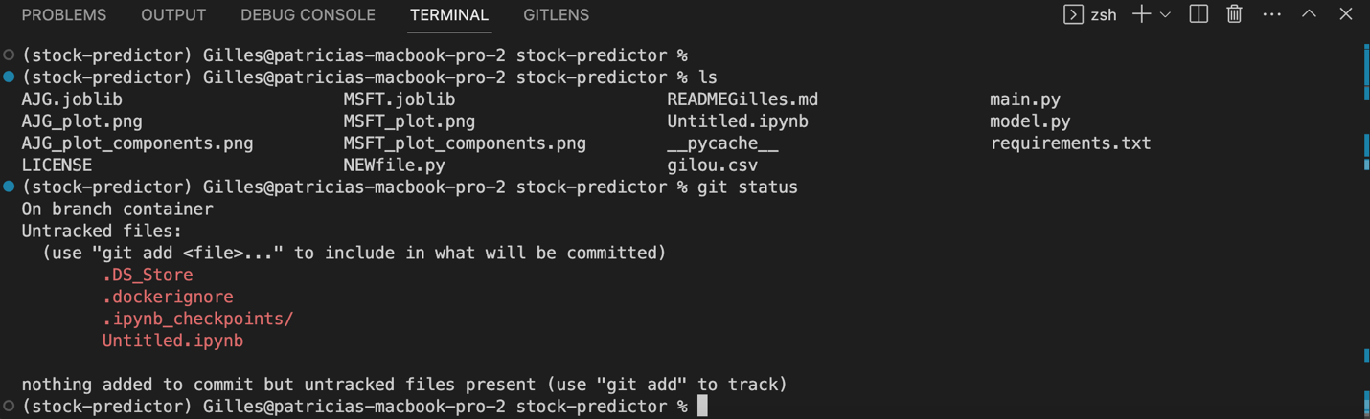

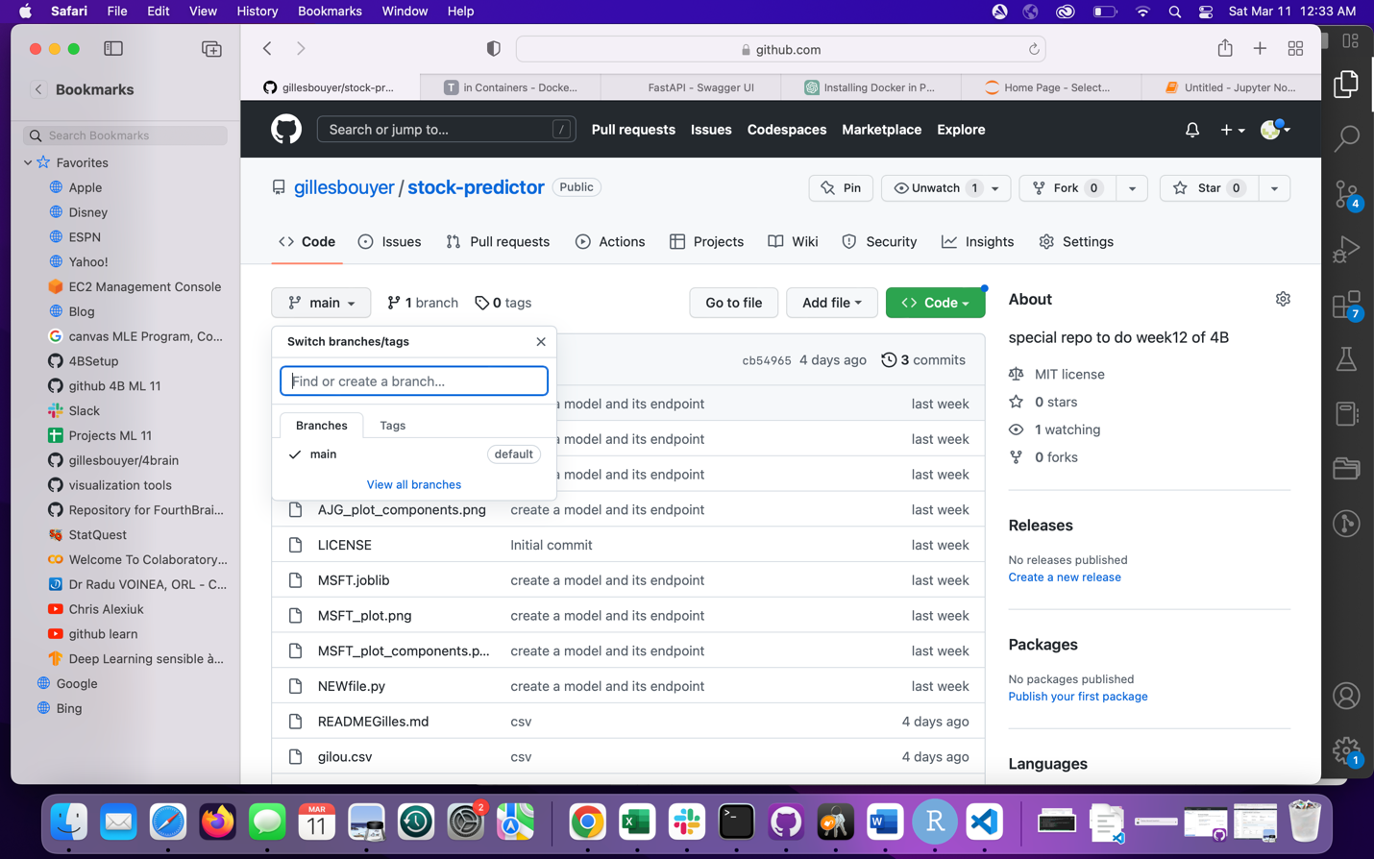

(stock-predictor) Gilles@patricias-macbook-pro-2 stock-predictor % git add .

(stock-predictor) Gilles@patricias-macbook-pro-2 stock-predictor % git commit -m 'docker1'

[container 5681d50] docker1

4 files changed, 70 insertions(+)

create mode 100644 .DS_Store

create mode 100644 .dockerignore

create mode 100644 .ipynb_checkpoints/Untitled-checkpoint.ipynb

create mode 100644 Untitled.ipynb

(stock-predictor) Gilles@patricias-macbook-pro-2 stock-predictor % git push

fatal: The current branch container has no upstream branch.

To push the current branch and set the remote as upstream, use

git push --set-upstream origin container

To have this happen automatically for branches without a tracking

upstream, see 'push.autoSetupRemote' in 'git help config'.

(stock-predictor) Gilles@patricias-macbook-pro-2 stock-predictor % git push --set-upstream origin container

Enumerating objects: 8, done.

Counting objects: 100% (8/8), done.

Delta compression using up to 2 threads

Compressing objects: 100% (6/6), done.

Writing objects: 100% (7/7), 1.31 KiB | 46.00 KiB/s, done.

Total 7 (delta 1), reused 0 (delta 0), pack-reused 0

remote: Resolving deltas: 100% (1/1), completed with 1 local object.

remote:

remote: Create a pull request for 'container' on GitHub by visiting:

remote: https://github.com/gillesbouyer/stock-predictor/pull/new/container

remote:

To https://github.com/gillesbouyer/stock-predictor.git

* [new branch] container -> container

branch 'container' set up to track 'origin/container'.

(stock-predictor) Gilles@patricias-macbook-pro-2 stock-predictor %

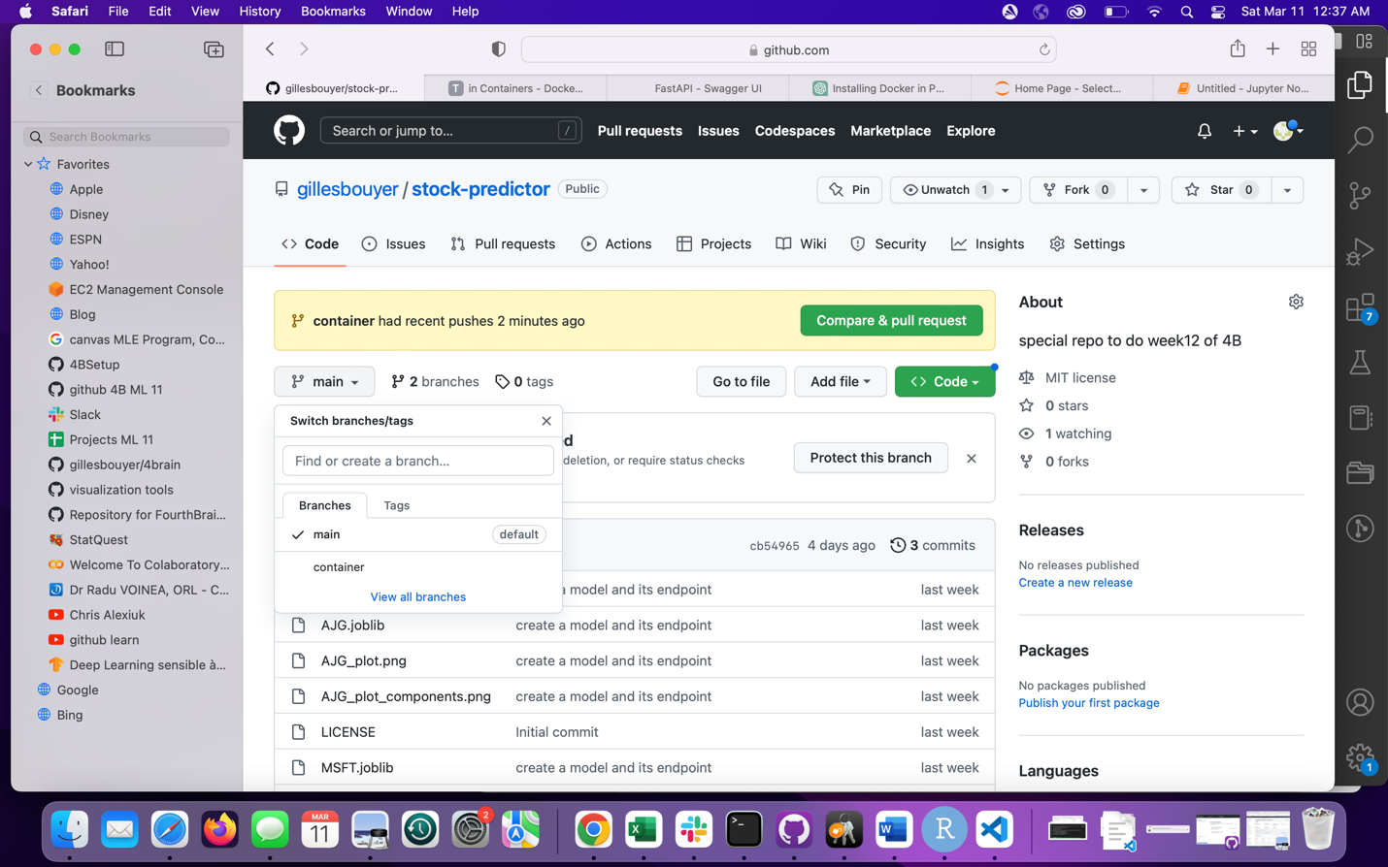

ACCOUNT IN DOCKER

<https://login.docker.com/u/login/identifier?state=hKFo2SBvazFWS21Da2l1ZEVUbHVDZmZiclVpQm85bHNUUmpxd6Fur3VuaXZlcnNhbC1sb2dpbqN0aWTZIDF0T3pSb0pIVHA5cDJrT1JSZlA4VVB6Tk1tUnBYd0lwo2NpZNkgbHZlOUdHbDhKdFNVcm5lUTFFVnVDMGxiakhkaTluYjk>

https://login.docker.com/u/login/identifier?state=hKFo2SBvazFWS21Da2l1ZEVUbHVDZmZiclVpQm85bHNUUmpxd6Fur3VuaXZlcnNhbC1sb2dpbqN0aWTZIDF0T3pSb0pIVHA5cDJrT1JSZlA4VVB6Tk1tUnBYd0lwo2NpZNkgbHZlOUdHbDhKdFNVcm5lUTFFVnVDMGxiakhkaTluYjk

gillesbouyer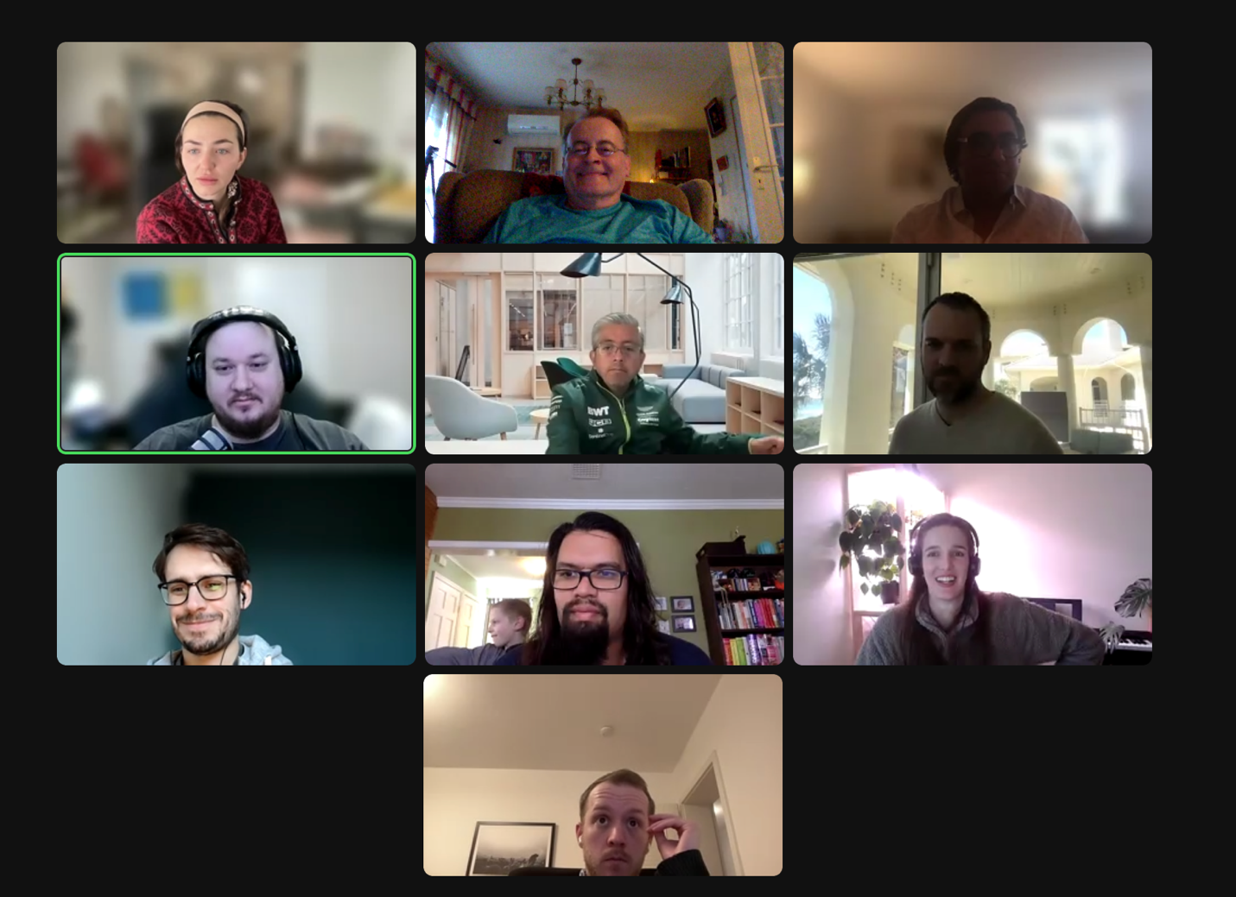

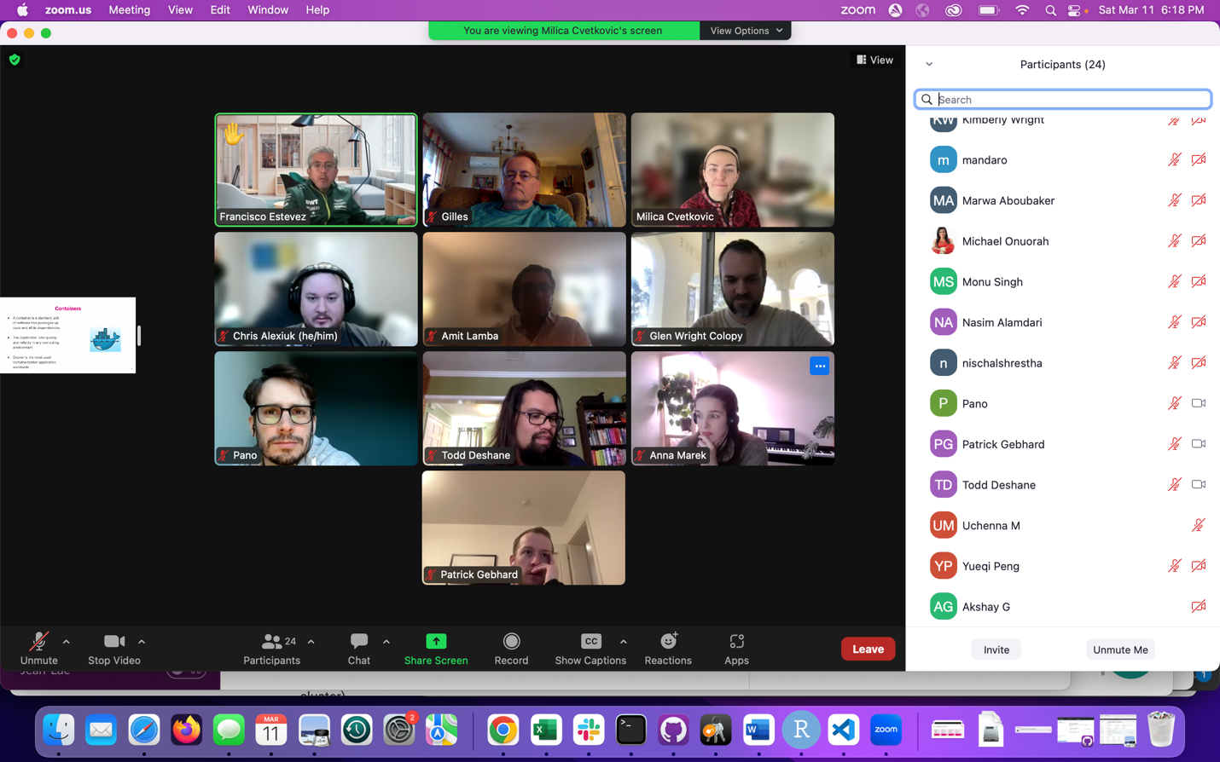

Gallagher5%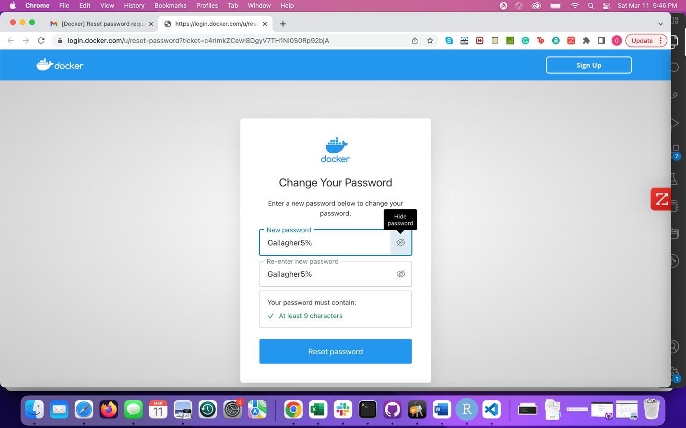

Docker most popular / Kubernetes for orchestration

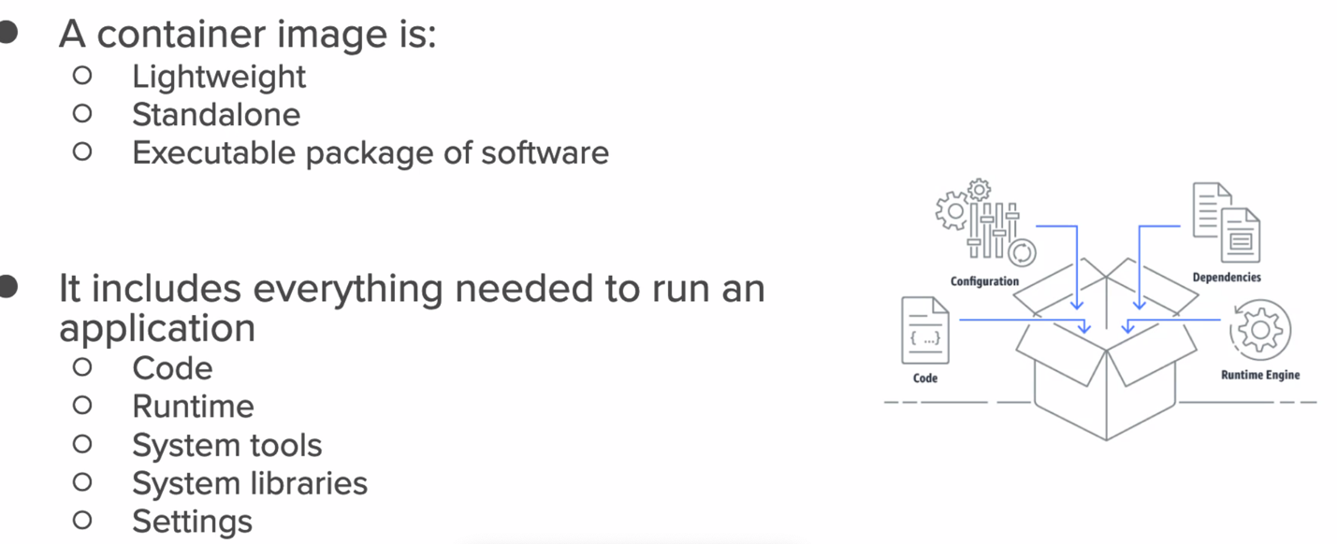

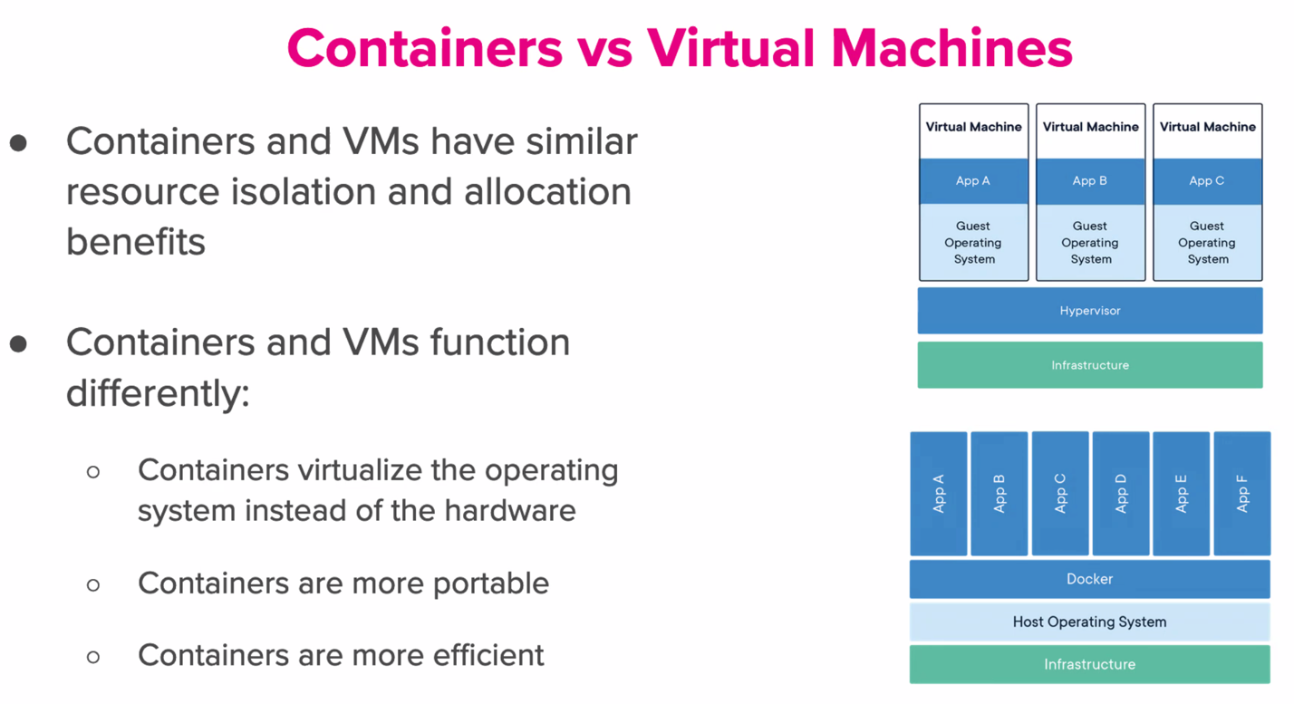

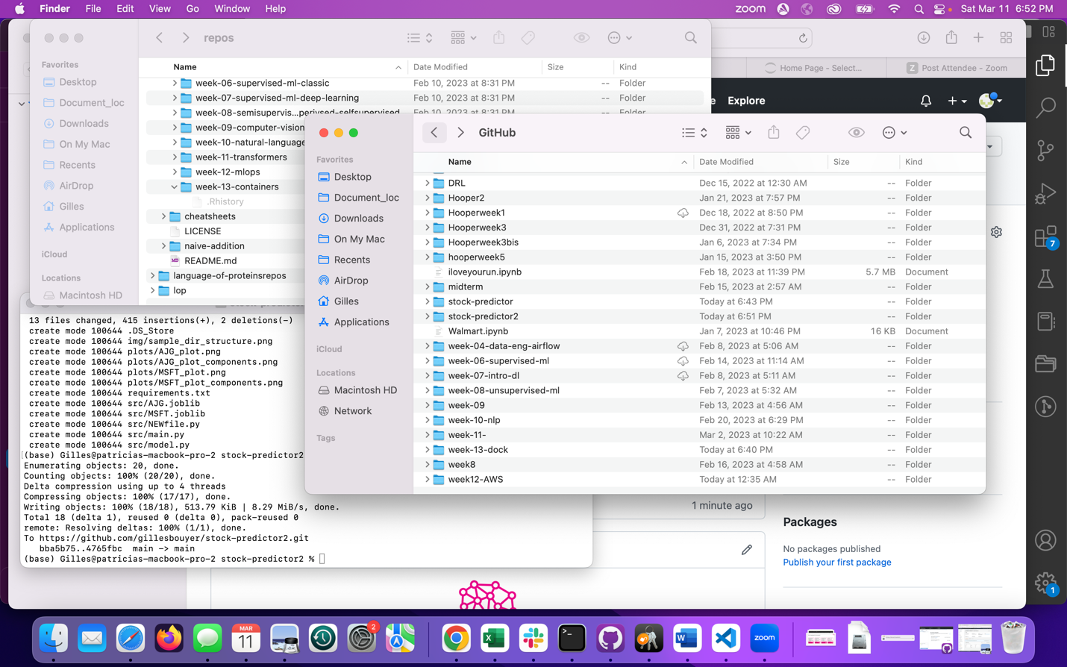

Streamlit and Gradio are tools that enable that kind of flex role, which means people expect it...

<https://www.smarthomebeginner.com/>

[https://www.smarthomebeginner.com/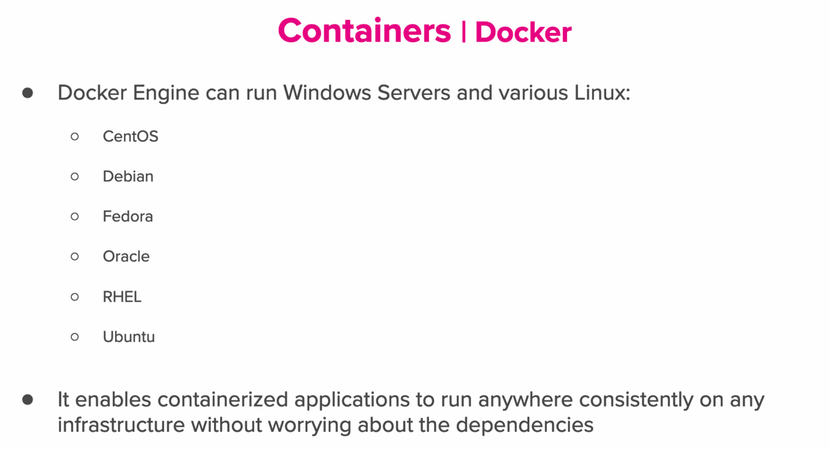](https://www.smarthomebeginner.com/)

<https://helm.sh/>

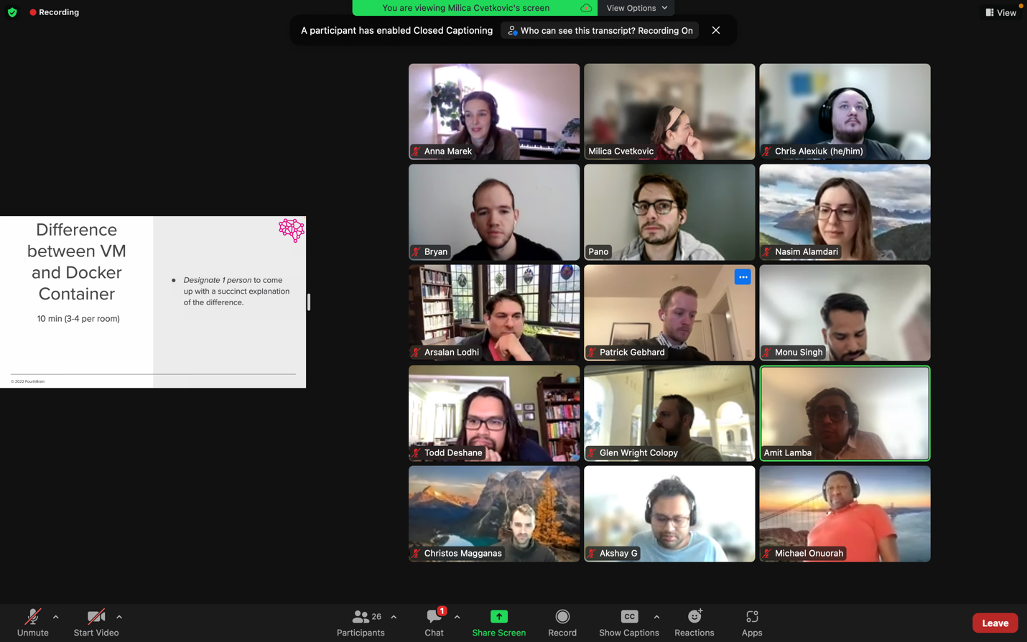

You can reuse pytorch images as layers on layers (containers)

You can specifically stack microservices / front end-backend/ pub sub

They all, thankfully, rely on the OCI standards. https://opencontainers.org/

So a lot of these tools are relatively plug and play.

Design Pattern - loosley coupled micro services . pub/sub - publisher and subscriber of each topic. Another common example: API (e.g. fastapi or nodeJS) and then a frontend website (e.g. react, vue, angular)

<https://sylabs.io/singularity-pro/>

From my experience, HPC admins don’t like to give root access, so docker is not directly an option, but containers via singularity or enroot are cool container options

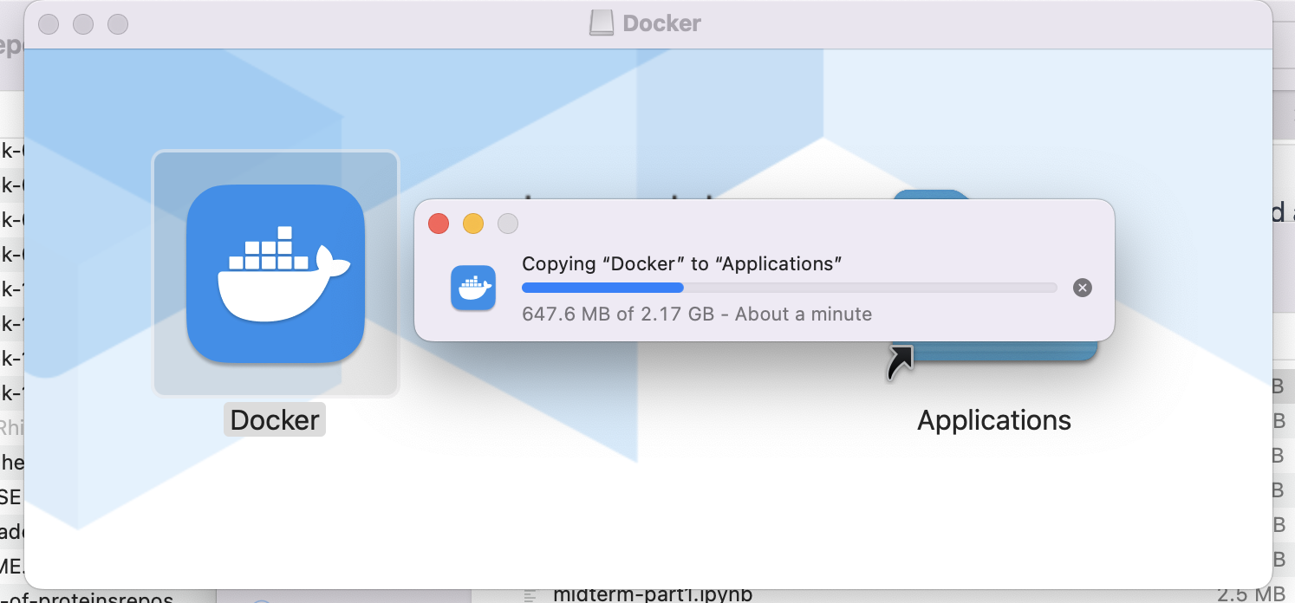

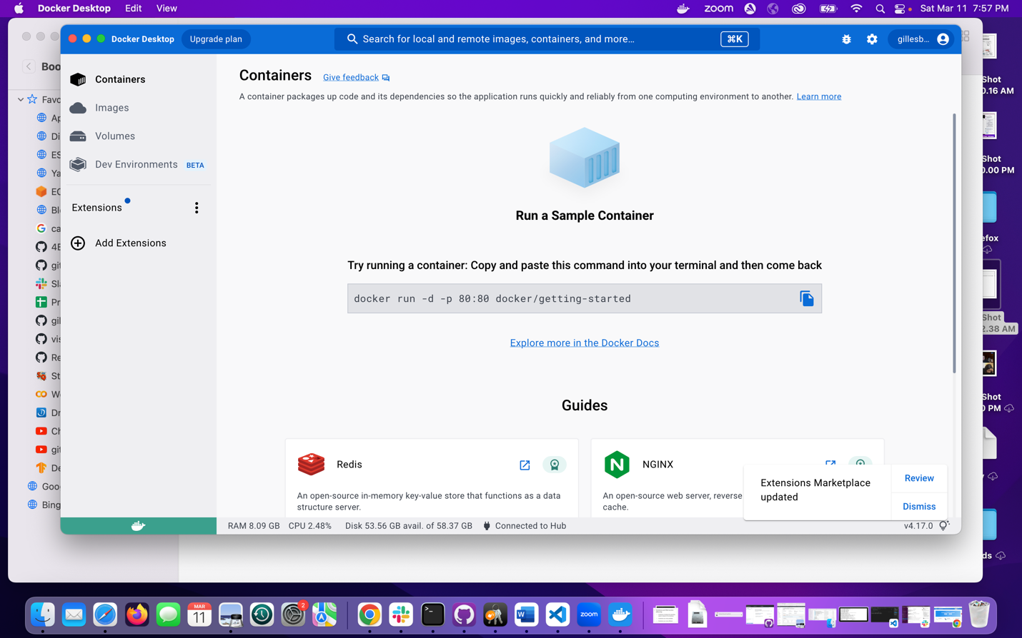

docker run -d -p 80:80 docker/getting-started

(base) Gilles@patricias-macbook-pro-2 stock-predictor2 % docker run -d -p 80:80 docker/getting-started

Unable to find image 'docker/getting-started:latest' locally

latest: Pulling from docker/getting-started

c158987b0551: Pull complete

1e35f6679fab: Pull complete

cb9626c74200: Pull complete

b6334b6ace34: Pull complete

f1d1c9928c82: Pull complete

9b6f639ec6ea: Pull complete

ee68d3549ec8: Pull complete

33e0cbbb4673: Pull complete

4f7e34c2de10: Pull complete

Digest: sha256:d79336f4812b6547a53e735480dde67f8f8f7071b414fbd9297609ffb989abc1

Status: Downloaded newer image for docker/getting-started:latest

d7f9eeeb6a383b7104027e50d75098f411dad32f19639c54bf7ba0369465ae28

(base) Gilles@patricias-macbook-pro-2 stock-predictor2 %

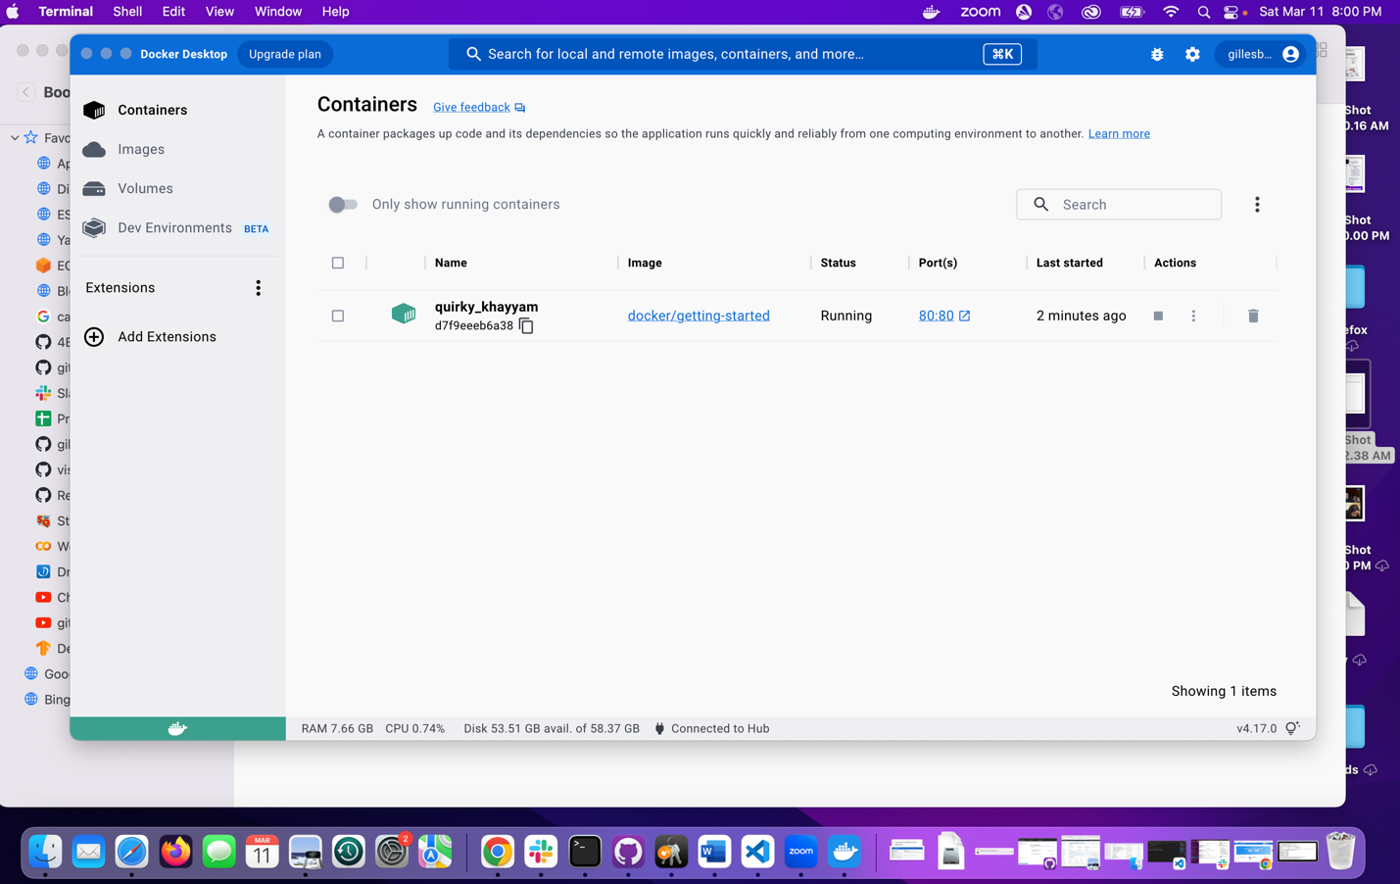

80:80 localhost:80

[http://localhost/tutorial/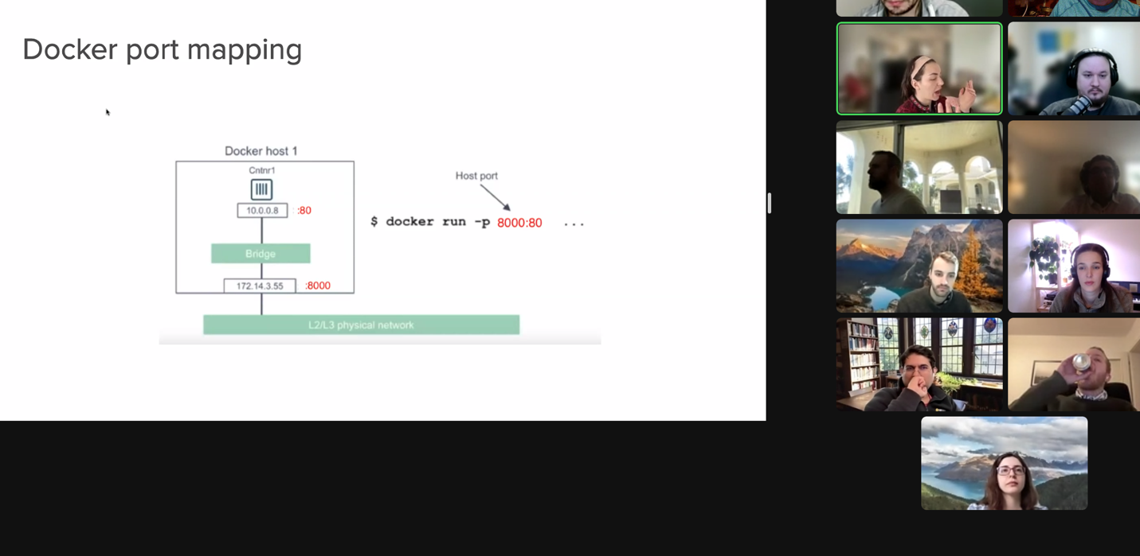](http://localhost/tutorial/)

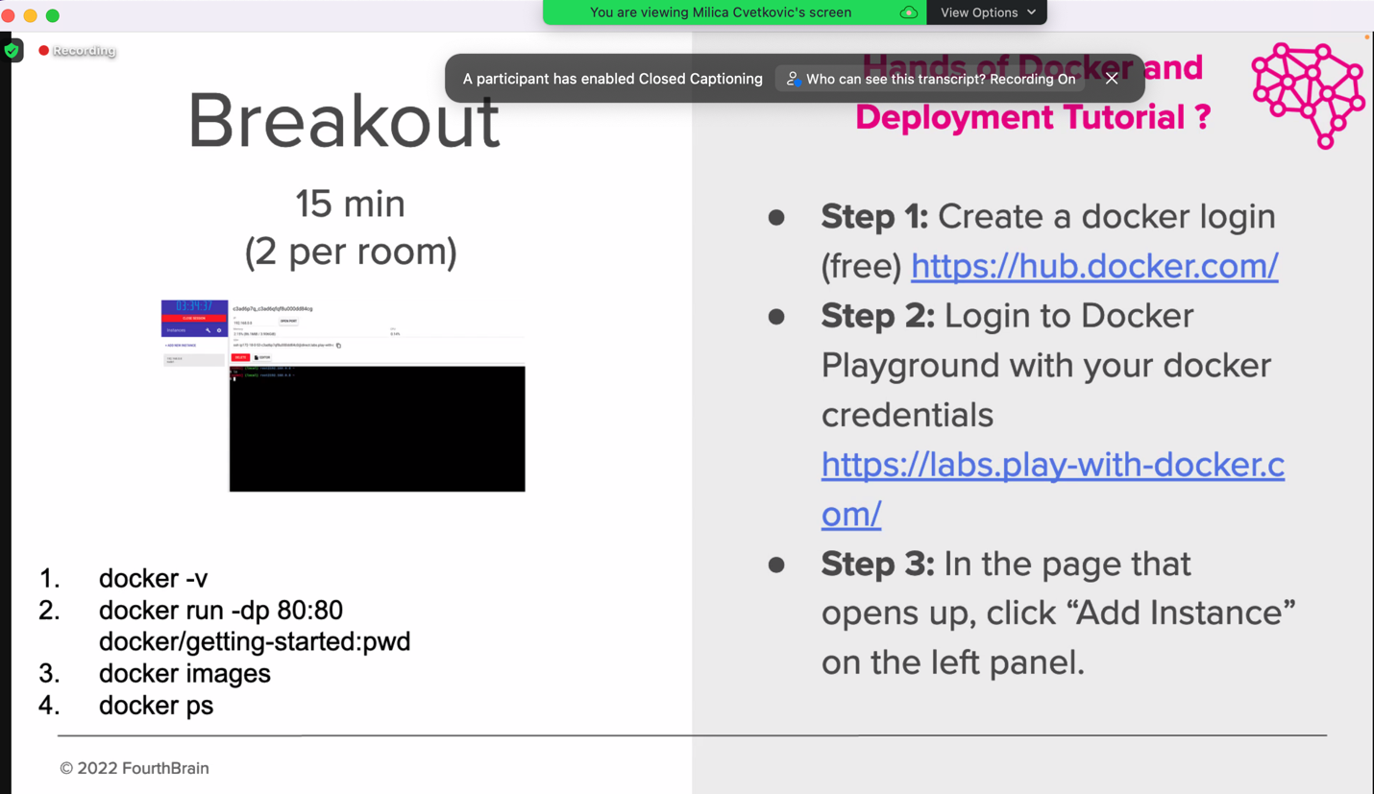

<https://labs.play-with-docker.com/p/cg6d4kg1k7jg00f01kq0#cg6d4kg1_cg6d4o81k7jg00f01kr0>

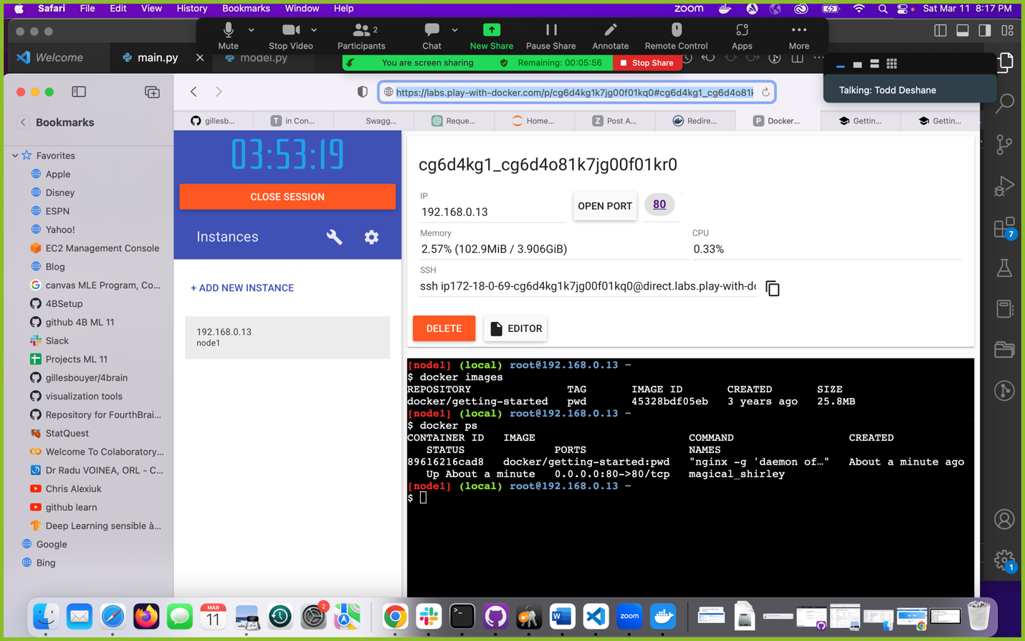

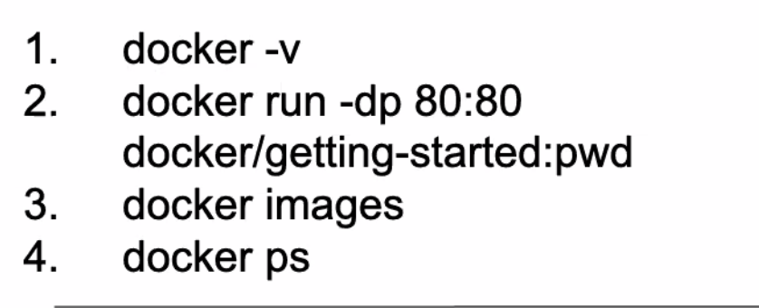

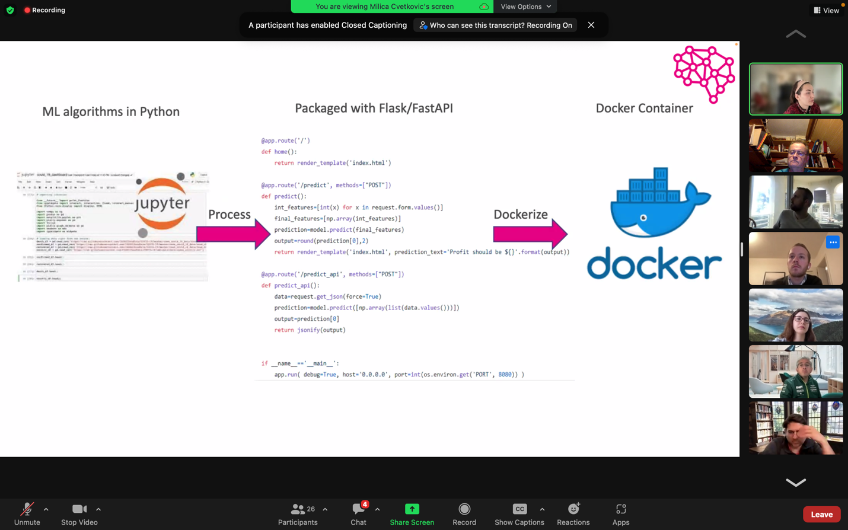

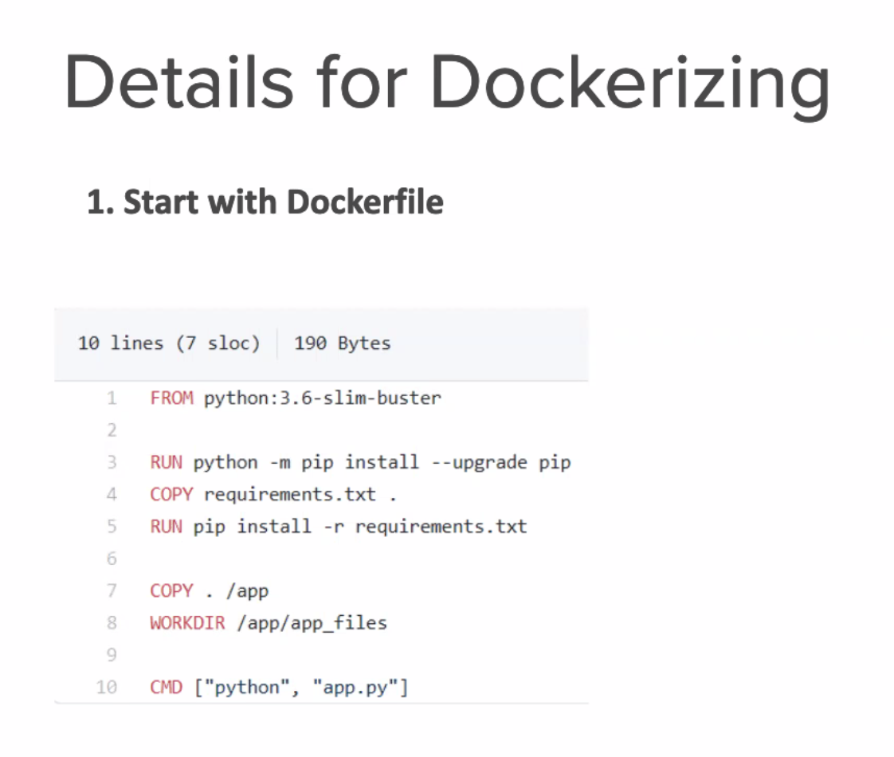

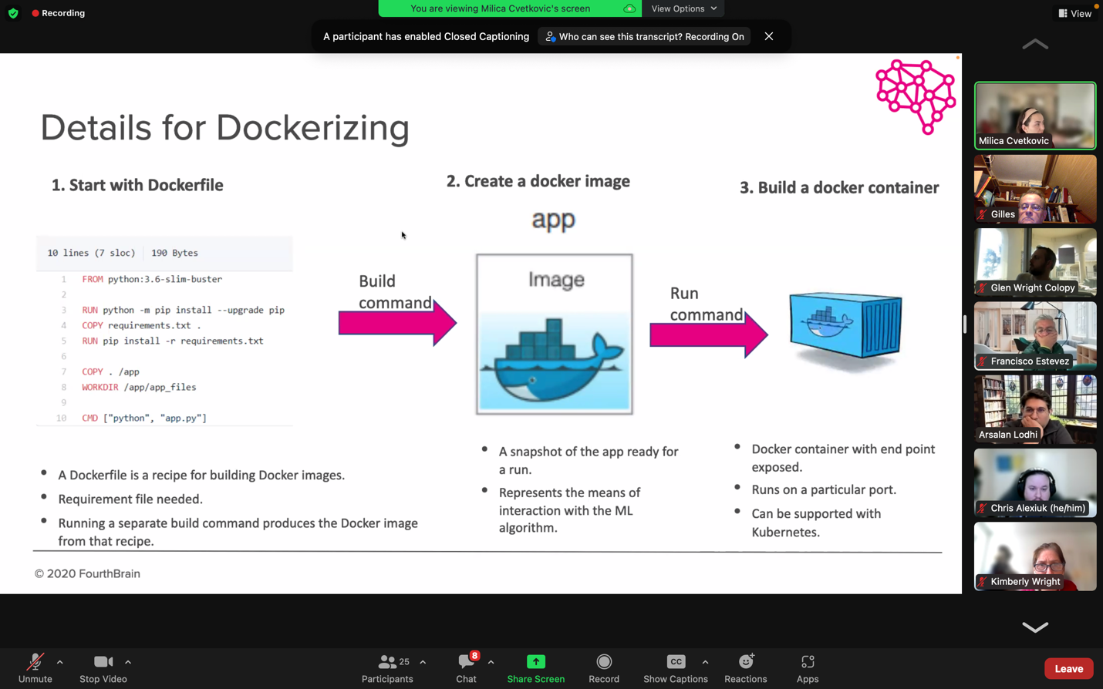

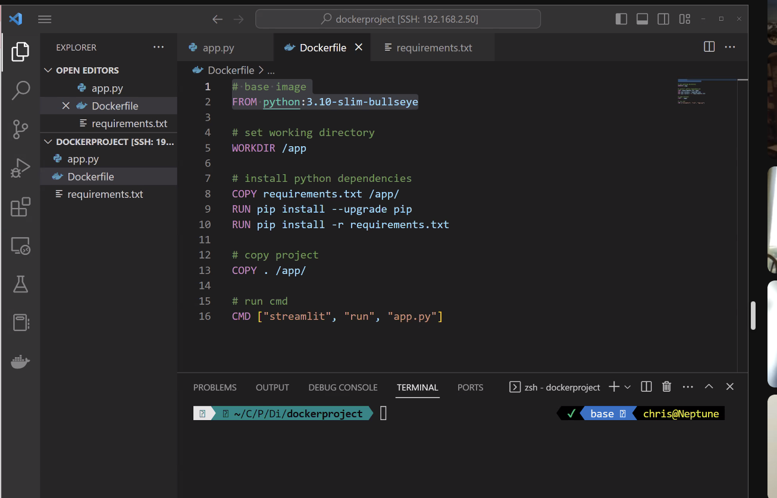

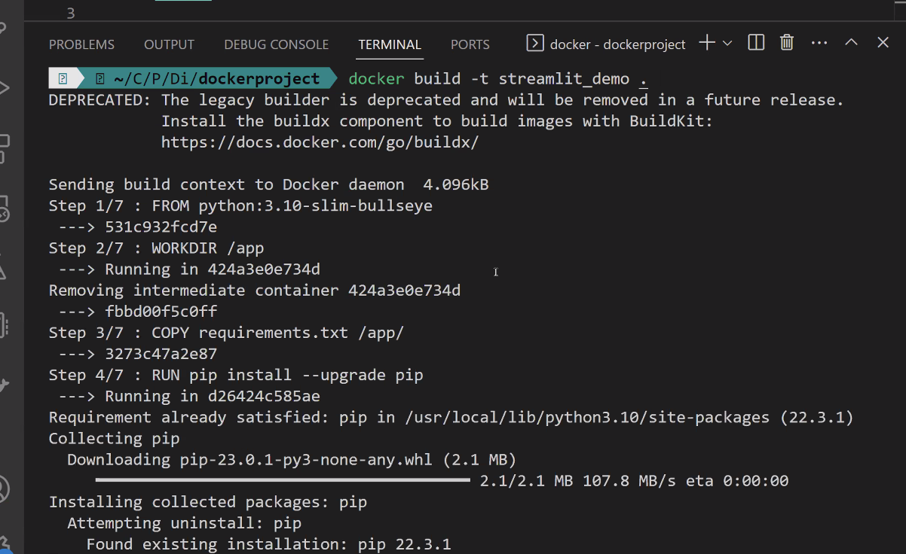

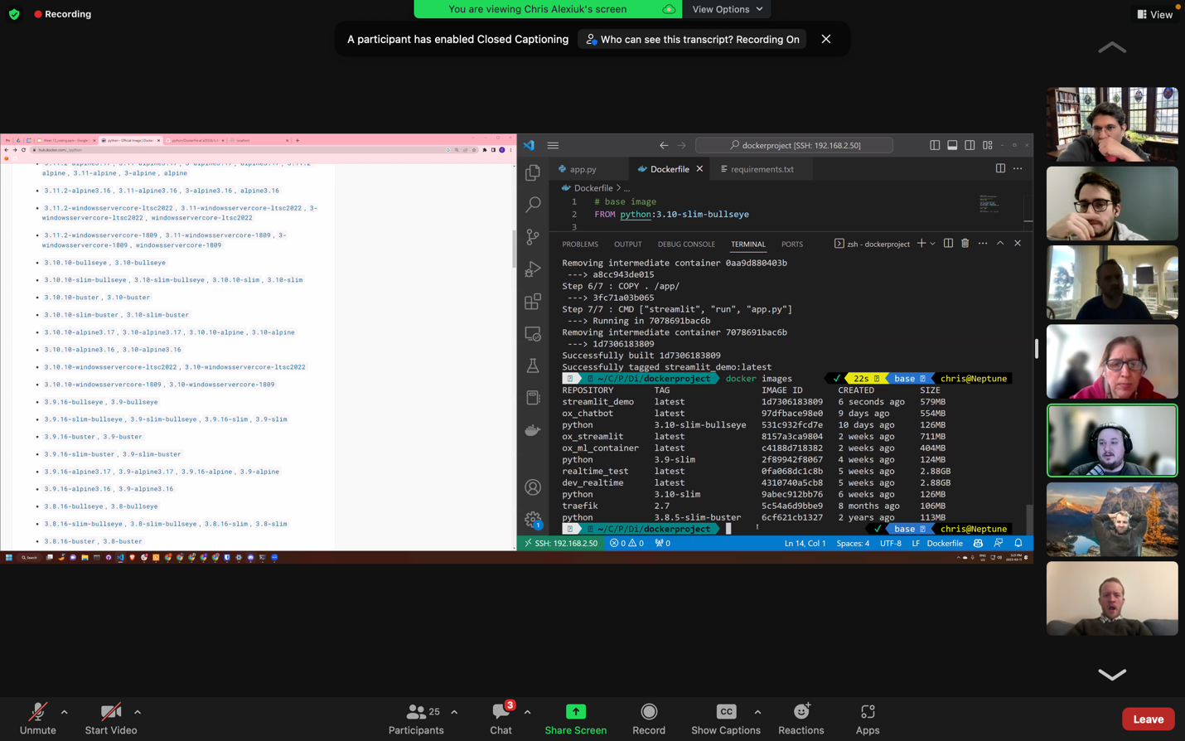

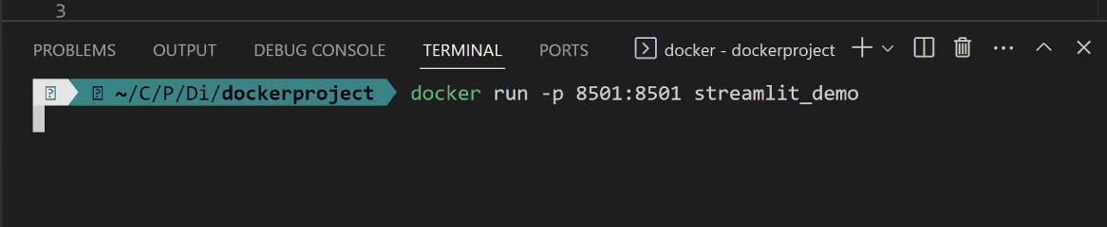

echo "__pycache__\nenv\n.pem" > .dockerignore

(stock-predictor) Gilles@patricias-macbook-pro-2 stock-predictor2 % docker build -t stock-prophet .

[+] Building 365.2s (15/15) FINISHED

=> [internal] load build definition from Dockerfile 0.2s

=> => transferring dockerfile: 588B 0.1s

=> [internal] load .dockerignore 0.1s

=> => transferring context: 61B 0.0s

=> [internal] load metadata for docker.io/library/python:3.8 2.5s

=> [auth] library/python:pull token for registry-1.docker.io 0.0s

=> [ 1/10] FROM docker.io/library/python:3.8@sha256:03755bc833034d91e6611f8059c38626184cd365d4f5783d28db24cd0a9ca817 136.1s

=> => resolve docker.io/library/python:3.8@sha256:03755bc833034d91e6611f8059c38626184cd365d4f5783d28db24cd0a9ca817 0.0s

=> => sha256:32fb02163b6bb519a30f909008e852354dae10bdfd6b34190dbdfe8f15403ea0 55.05MB / 55.05MB 25.6s

=> => sha256:167c7feebee855d117e192389484ea8367be1ba84e7ee35f4e5e5663195facbf 5.17MB / 5.17MB 3.3s

=> => sha256:d6dfff1f6f3ddd2194ea0775f199572e8b2d75c38713eef0444d6b1fd0ac7604 10.88MB / 10.88MB 5.8s

=> => sha256:03755bc833034d91e6611f8059c38626184cd365d4f5783d28db24cd0a9ca817 1.86kB / 1.86kB 0.0s

=> => sha256:c4e2cd82742855db60bcac50f414cf62527925a2c54915ff54add6f8aaa25ce7 2.22kB / 2.22kB 0.0s

=> => sha256:37e2cb1c090b17898a0a610a7f41c996781348aca097f043220c97a24eba4200 8.86kB / 8.86kB 0.0s

=> => sha256:e9cdcd4942ebc7445d8a70117a83ecbc77dcc5ffc72c4b6f8e24c0c76cfee15d 54.59MB / 54.59MB 35.6s

=> => sha256:ca3bce705f6c47c25b6e7896b4da514bf271c5827b1d19f51611c4a149dd713c 196.81MB / 196.81MB 62.7s

=> => sha256:5e1c6c4f8bbf1116f692204567222e5b77b4d0275cccad0c6810eb4374aede6a 6.29MB / 6.29MB 32.1s

=> => extracting sha256:32fb02163b6bb519a30f909008e852354dae10bdfd6b34190dbdfe8f15403ea0 37.4s

=> => sha256:67ab6641db00d7e1fb5e57e4e0629cb788502c81b37ba3e5f8e86cc2aee76df0 15.81MB / 15.81MB 40.0s

=> => sha256:04492d20fe3ff481e0a3b32d2d32a1c67f15d3ee7b473dc6c5df989f03e87229 233B / 233B 36.7s

=> => sha256:f16ef22014484b86b1cff675d15ac62e197644cecf9555daa08701c6e9819313 2.88MB / 2.88MB 39.8s

=> => extracting sha256:167c7feebee855d117e192389484ea8367be1ba84e7ee35f4e5e5663195facbf 0.9s

=> => extracting sha256:d6dfff1f6f3ddd2194ea0775f199572e8b2d75c38713eef0444d6b1fd0ac7604 1.3s

=> => extracting sha256:e9cdcd4942ebc7445d8a70117a83ecbc77dcc5ffc72c4b6f8e24c0c76cfee15d 12.1s

=> => extracting sha256:ca3bce705f6c47c25b6e7896b4da514bf271c5827b1d19f51611c4a149dd713c 44.0s

=> => extracting sha256:5e1c6c4f8bbf1116f692204567222e5b77b4d0275cccad0c6810eb4374aede6a 1.1s

=> => extracting sha256:67ab6641db00d7e1fb5e57e4e0629cb788502c81b37ba3e5f8e86cc2aee76df0 6.2s

=> => extracting sha256:04492d20fe3ff481e0a3b32d2d32a1c67f15d3ee7b473dc6c5df989f03e87229 0.0s

=> => extracting sha256:f16ef22014484b86b1cff675d15ac62e197644cecf9555daa08701c6e9819313 1.1s

=> [internal] load build context 0.1s

=> => transferring context: 211.65kB 0.0s

=> [ 2/10] RUN apt-get -y update && apt-get install -y python3-dev apt-utils python-dev build-essential & 39.3s

=> [ 3/10] RUN pip install --no-cache-dir -U pip 17.1s

=> [ 4/10] RUN pip install --no-cache-dir -U cython 4.9s

=> [ 5/10] RUN pip install --no-cache-dir -U numpy 11.0s

=> [ 6/10] RUN pip install --no-cache-dir -U pystan 65.4s

=> [ 7/10] COPY requirements.txt . 0.1s

=> [ 8/10] RUN pip install --no-cache-dir -U -r requirements.txt 78.9s

=> [ 9/10] COPY src/ . 0.1s

=> exporting to image 9.2s

=> => exporting layers 9.2s

=> => writing image sha256:c1cebb17cd6d1cace097bd0143dfc9ae52c11fdbe633a3f9cfe91332f721e309 0.0s

=> => naming to docker.io/library/stock-prophet 0.0s

(stock-predictor) Gilles@patricias-macbook-pro-2 stock-predictor2 %

(stock-predictor) Gilles@patricias-macbook-pro-2 stock-predictor2 % docker image ls

REPOSITORY TAG IMAGE ID CREATED SIZE

stock-prophet latest c1cebb17cd6d 8 minutes ago 1.5GB

docker/getting-started latest 3e4394f6b72f 2 months ago 47MB

(stock-predictor) Gilles@patricias-macb ook-pro-2 stock-predictor2 %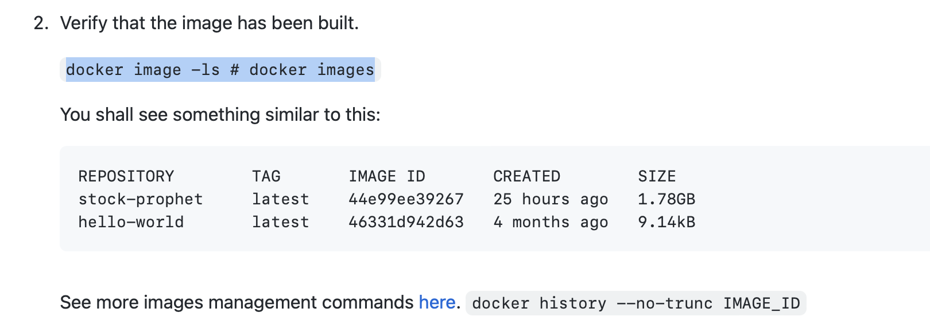

stock-predictor) Gilles@patricias-macbook-pro-2 stock-predictor2 % curl localhost:8000

curl: (7) Failed to connect to localhost port 8000 after 15 ms: Connection refused

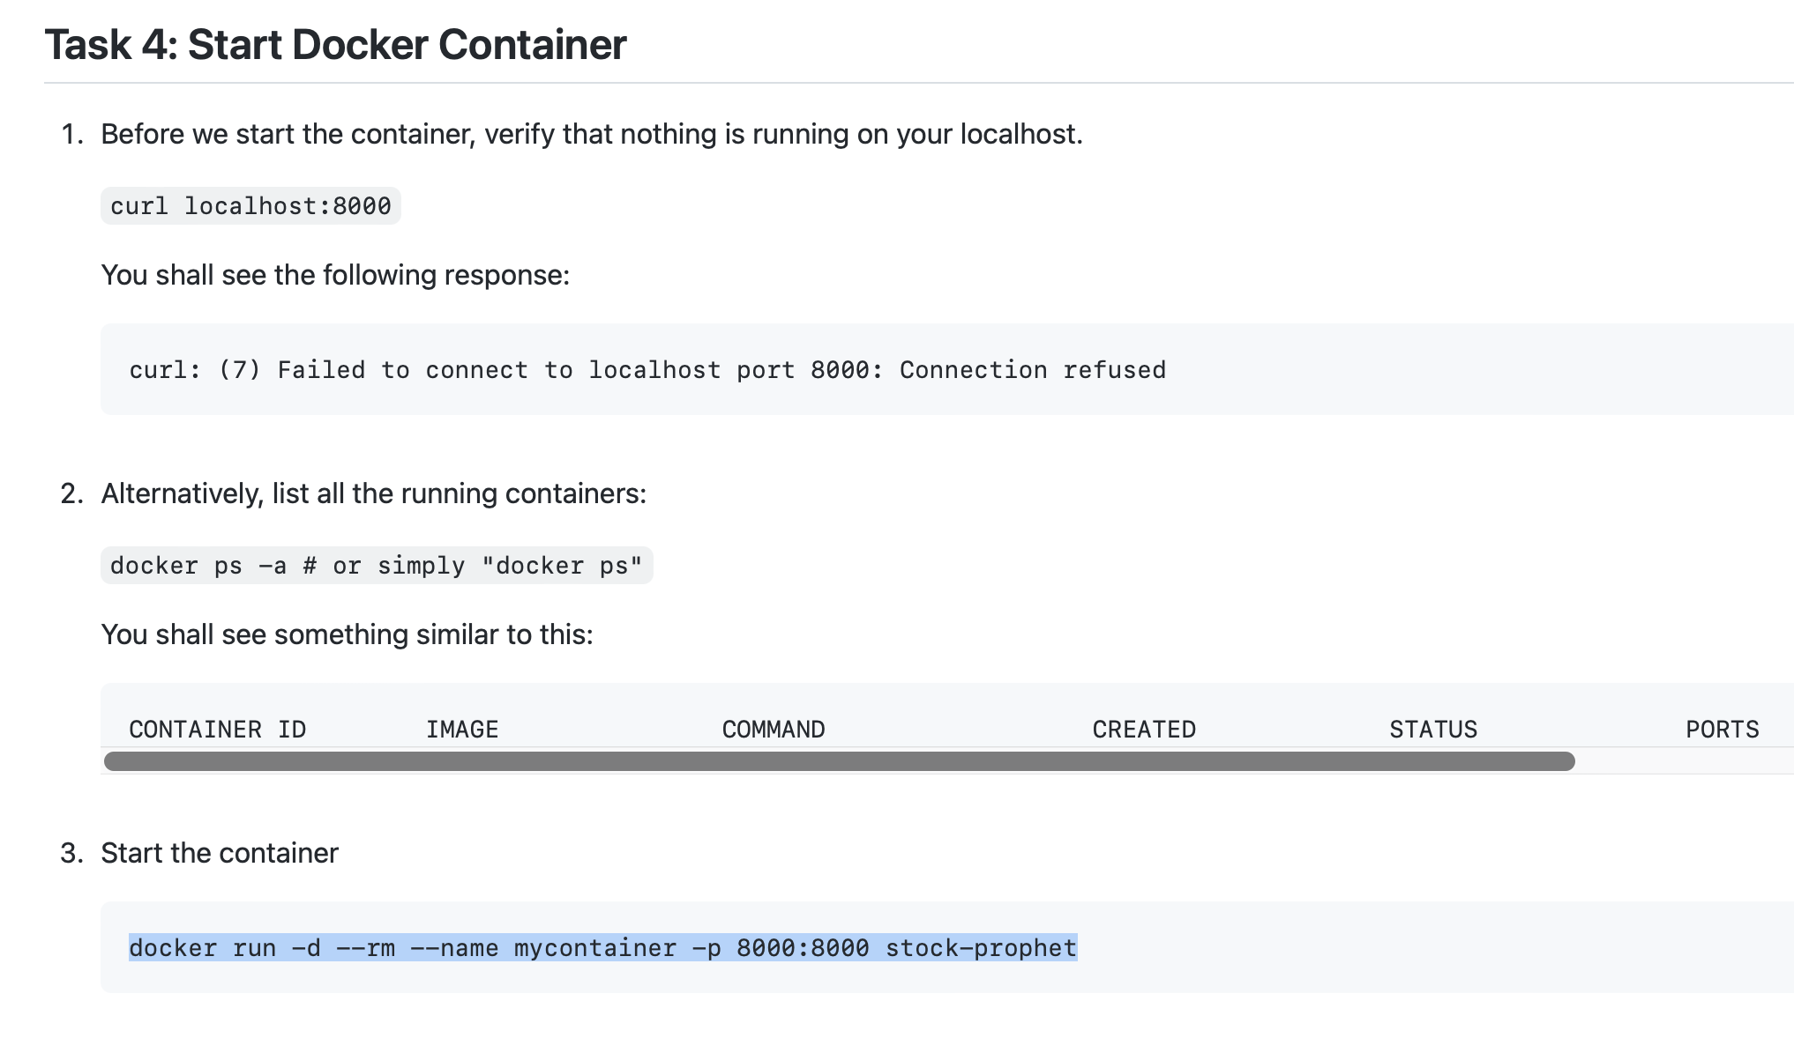

docker ps -a

CONTAINER ID IMAGE COMMAND CREATED STATUS PORTS NAMES

d7f9eeeb6a38 docker/getting-started "/docker-entrypoint.…" 3 hours ago Up 3 hours 0.0.0.0:80->80/tcp quirky_khayyam

(stock-predictor) Gilles@patricias-macbook-pro-2 stock-predictor2 % docker run -d --rm --name mycontainer -p 8000:8000 stock-prophet

8c3e16af3624214e3faea0d90430dc91872a9c25989672ebc630af52abc18191

(stock-predictor) Gilles@patricias-macbook-pro-2 stock-predictor2 % docker ps -a

CONTAINER ID IMAGE COMMAND CREATED STATUS PORTS NAMES

8c3e16af3624 stock-prophet "uvicorn main:app --…" 31 seconds ago Up 29 seconds 0.0.0.0:8000->8000/tcp mycontainer

d7f9eeeb6a38 docker/getting-started "/docker-entrypoint.…" 3 hours ago Up 3 hours 0.0.0.0:80->80/tcp quirky_khayyam

(stock-predictor) Gilles@patricias-macbook-pro-2 stock-predictor2 % curl \

--header "Content-Type: application/json" \

--request POST \

--data '{"ticker":"MSFT", "days":7}' \

http://localhost:8000/predict

{"ticker":"MSFT","days":7,"forecast":{"03/12/2023":244.71546209428655,"03/13/2023":244.69628109047102,"03/14/2023":244.67710008665543,"03/15/2023":244.65791908283984,"03/16/2023":244.6387380790243,"03/17/2023":244.61955707520872,"03/18/2023":244.60037607139316}}

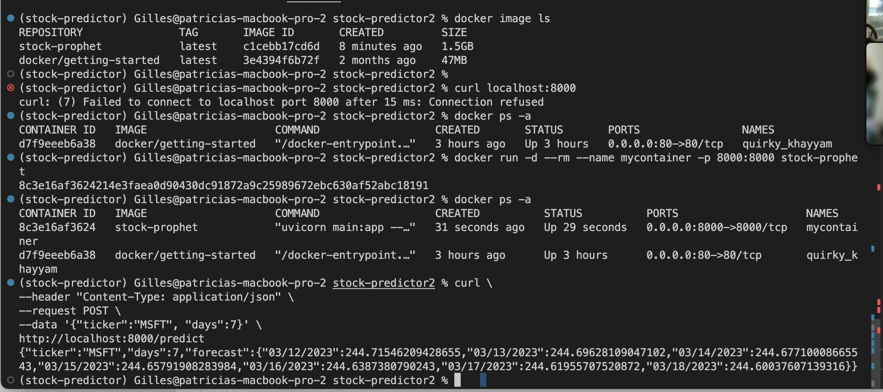

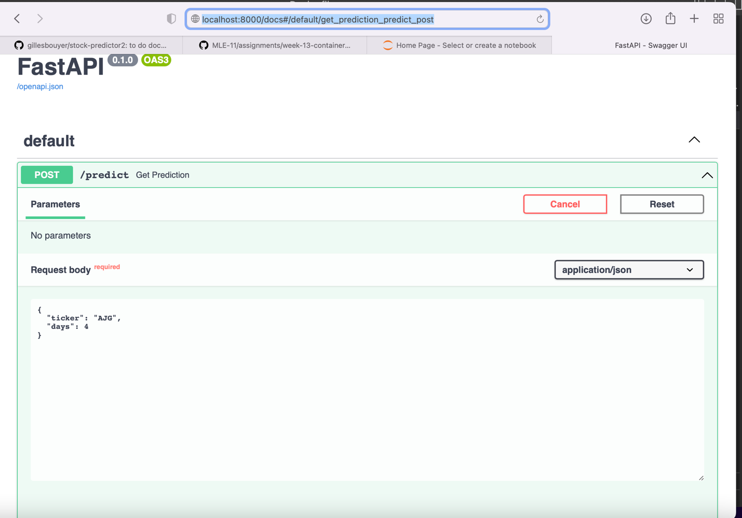

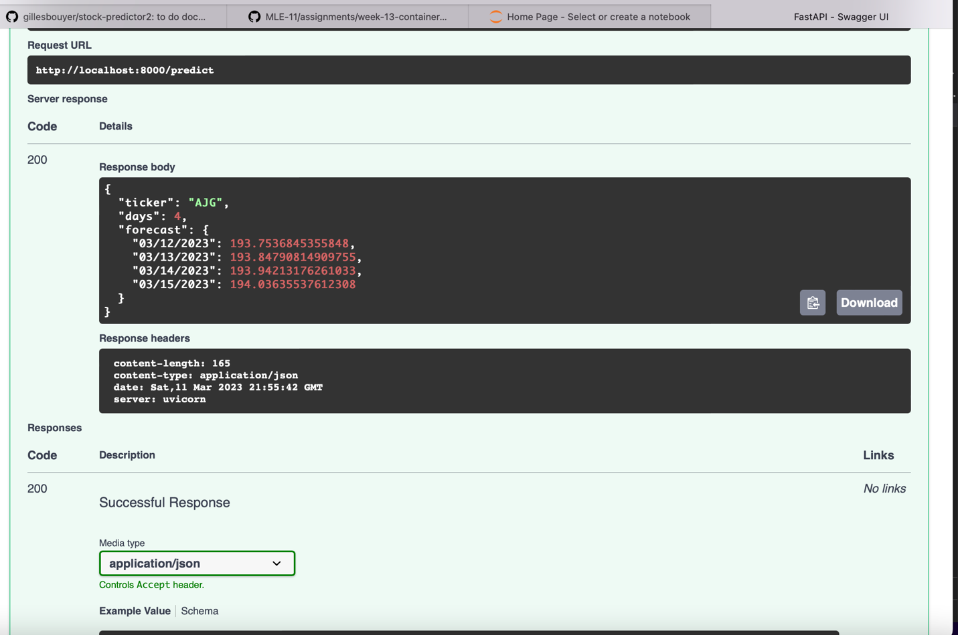

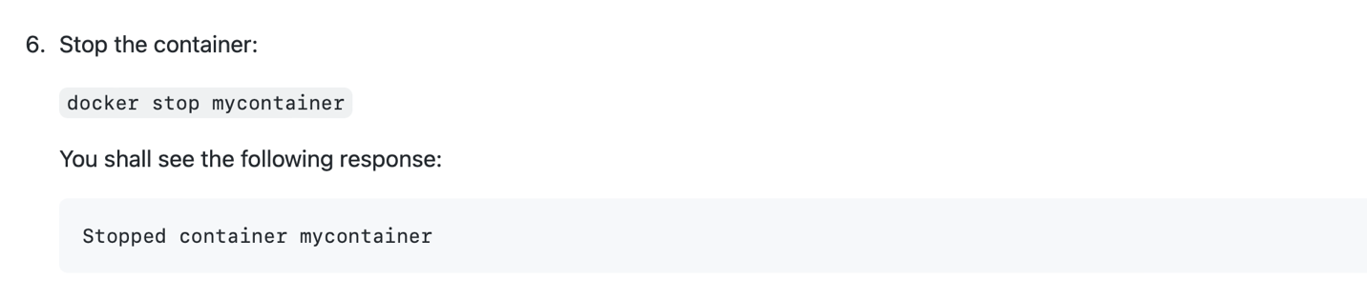

(stock-predictor) Gilles@patricias-macbook-pro-2 stock-predictor2 % docker stop mycontainer

mycontainer

(stock-predictor) Gilles@patricias-macbook-pro-2 stock-predictor2 % docker ps -a

CONTAINER ID IMAGE COMMAND CREATED STATUS PORTS NAMES

d7f9eeeb6a38 docker/getting-started "/docker-entrypoint.…" 3 hours ago Up 3 hours 0.0.0.0:80->80/tcp quirky_khayyam

(stock-predictor) Gilles@patricias-macbook-pro-2 stock-predictor2 % docker run -d --rm --name mycontainer -p 8000:8000 stock-prophet

5439d9cb2c6247905b1a2b49f293f7c68fc184e9df2819439df4b2f108b774c1

(stock-predictor) Gilles@patricias-macbook-pro-2 stock-predictor2 % docker ps -a

CONTAINER ID IMAGE COMMAND CREATED STATUS PORTS NAMES

5439d9cb2c62 stock-prophet "uvicorn main:app --…" 6 seconds ago Up 5 seconds 0.0.0.0:8000->8000/tcp mycontainer

d7f9eeeb6a38 docker/getting-started "/docker-entrypoint.…" 3 hours ago Up 3 hours 0.0.0.0:80->80/tcp quirky_khayyam

(stock-predictor) Gilles@patricias-macbook-pro-2 stock-predictor2 % docker stop quirky_khayyam

quirky_khayyam

(stock-predictor) Gilles@patricias-macbook-pro-2 stock-predictor2 % docker stop mycontainer

mycontainer

(stock-predictor) Gilles@patricias-macbook-pro-2 stock-predictor2 % docker ps -a

CONTAINER ID IMAGE COMMAND CREATED STATUS PORTS NAMES

d7f9eeeb6a38 docker/getting-started "/docker-entrypoint.…" 3 hours ago Exited (0) 10 seconds ago quirky_khayyam

(stock-predictor) Gilles@patricias-macbook-pro-2 stock-predictor2 % docker ps -a

CONTAINER ID IMAGE COMMAND CREATED STATUS PORTS NAMES

d7f9eeeb6a38 docker/getting-started "/docker-entrypoint.…" 3 hours ago Exited (0) 6 minutes ago quirky_khayyam